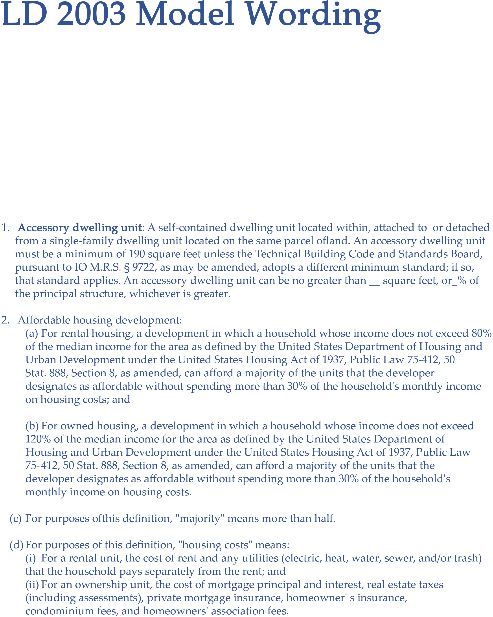

Disclaimer: This model wording is intended to be an example and should be reviewed and revised by the appropriate parties prior to being implemented by the municipality.

* If a town states that only one dwelling unit per lot is permitted, this must be removed.
* A town must allow one ADU on the same lot as a single-family dwelling.
* It is recommended that the town set a minimum lot area per dwelling unit.
* It is recommended that towns set a maximum size for ADU' s.
* All the requirements of shoreland zoning still apply.
* Proof of potable water/suﬃcient sewer capacity is required for increased housing density and ADUs.

# Deﬁnitions

* 1. **Area median income:** The midpoint of a region's income distribution calculated on an annual basis by the U.S. Department of Housing & Urban Development.
  2. **Attached:** Connected by a shared wall to the principal structure.
  3. **Base density:** The maximum number of units allowed on a lot not used for affordable housing based on dimensional requirements in Chapter 5 (Subdivision Ordinance) or the Shoreland Zoning Ordinance, as applicable.
  4. **Centrally managed water system:** A water system that provides water for human consumption through pipes or other constructed conveyances to at least 15 service connections or serves an average of at least 25 people for at least 60 days a year as regulated by 10-144 C.M.R. Ch. 231, Rules Relating to Drinking Water. This water system may be privately owned.
  5. **Comparable sewer system:** Any subsurface wastewater disposal system that discharges over 2,000 gallons of wastewater per day as regulated by 10-144 C.M.R. Ch. 241, Subswface Wastewater Disposal Rules.
  6. **Density requirements:** The maximum number of dwelling units allowed on a lot, subject to dimensional requirements.
  7. **Designated growth area:** Any area that is designated in the Town's Comprehensive Plan as suitable for orderly residential, commercial, or industrial development, or any combination of those types of development, and into which most development projected over ten (I 0) years is directed. Designated growth areas may also be referred to as priority development zones or other terms with a similar intent.
  8. **Dimensional requirements:** Numerical standards relating to spatial relationships including, but not limited to, setback, lot area, shore frontage, road frontage, lot depth and height.
  9. **Dwelling unit:** Any part of a structure which, through sale or lease, is intended for human habitation, including single-family and multi-family housing, condominiums, time-share units, and apartments.
  10. **Existing dwelling unit:** A residential unit in existence on a lot at the time of submission of a permit application to build additional units on that lot. If a municipality does not have a permitting process, the dwelling unit on a lot must be in existence at the time construction begins for additional units on a lot.
  11. **Housing:** Any part of a structure which, through sale or lease, is intended for human habitation, including single-family and multi-family housing, condominiums, time-share units, and apartments. For purposes of this rule, this does not include dormitories, boarding houses or other similar types of housing units. This also does not include transient housing or short-term rentals, unless these uses are otherwise allowed in local ordinance.
  12. **Lot:** A single parcel of developed or undeveloped land described **in** a deed or other legal instrument.
  13. **Multi-family dwelling:** A structure containing three (3) or more dwelling units.

# LAND USE STANDARDS- SECTION LANGUAGE

***this can be made into a new chapter or worked into an existing ordinance section****

RESIDENTIAL DENSITY

The following provisions apply to allow multiple dwelling units on lots where housing is allowed as of July I, 2024 and thereafter.

I. If the lot contains one (I) existing dwelling unit, up to two additional dwelling units may be constructed, notwithstanding the requirements of (Subdivision Ordinance). The additional units may be located within, attached to, or detached from the existing structure. The owner may also choose to have one unit detached and one unit attached to the existing structure. If the third dwelling unit is created within a 5-year period, the project may be subject to additional subdivision review and approval.

2. If the lot contains two (2) or more existing dwelling units, no more additional units are

1. Water and Wastewater

I. Prior to occupancy, the owner of a housing structure must provide written veriﬁcation to the Code Enforcement Oﬃcer that the structure is connected to adequate water and wastewater services. Written veriﬁcation under this subsection must include the following:

* 1. If a housing structnre is connected to a public, special district or other comparable sewer system, proof of adequate service to support any additional ﬂow created by the structnre and proof of payment for the connection to the sewer system;
  2. If a housing structnre is connected to a septic system, proof of adequate sewage disposal for subsurface wastewater. The septic system must be veriﬁed as adequate by the Local Plumbing Inspector pursuant to 30-A M.R.S. § 4221, as may be amended. Plans for subsurface wastewater disposal must be prepared by a licensed site evaluator in accordance with 10-144

C.M.R. Ch. 241, Subswface Wastewater Disposal Rules;

* 1. If a housing structnre is connected to a public, special district or other centrally managed water system, proof of adequate service to support any additional ﬂow created by the structure, proof of payment for the connection and the volume and supply of water required for the structure; and

( d) If a housing structnre is connected to a well, proof of access to potable water, including the standards outlined in 01-672 C.M.R. Ch. 10 § 10.25(J), Land Use Districts and Standards, as may be amended. Any test of an existing well or proposed well mnst indicate that the water supply is potable and acceptable for domestic use.

1. Shoreland Zoning

This Section shall not be construed to exempt a property owner from the applicable provisions of shoreland zoning requirements established by the Maine Department of Environmental Protection under 38 M.R.S. Chapter 3 or the Town's Shoreland Zoning Ordinance.

1. Subdivision Requirements

This Section shall not be construed to exempt a property owner from the applicable provisions of the State subdivision statute, 30-A M.R.S. §§ 4401-4408, or (Subdivision Ordinance) relating to

division of a tract or parcel of land.

1. Restrictive Covenants

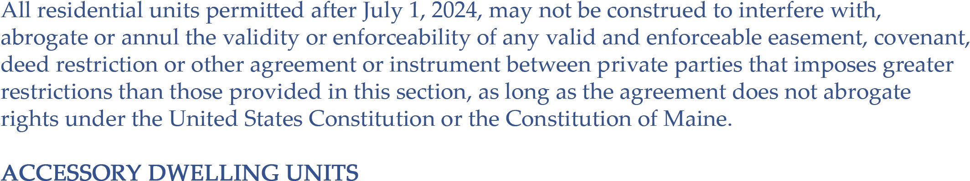

1. Requirements

A lot where a single-family dwelling unit is the principal structure may establish one accessory dwelling unit. The accessory dwelling unit is exempt from any density requirements or lot area requirements related to the area in which the accessory dwelling unit is constructed, except that for any accessory dwelling unit within the Shoreland Zone, it may only be established on a lot where the accessory dwelling unit itself can meet the minimum lot area and minimum shore frontage requirements of Section 15(A) (e.g., for a single family residence and an ADU on a lot in the Shoreland Zone, the lot must have twice the minimum lot area and twice the minimum shore frontage). An accessory dwelling unit must meet the setback requirements set forth in (section of Shoreland ordinance) if located within the Shoreland Zone and the setback requirements set forth in (section of building requirements).

1. Size

The accessory dwelling unit must be at least 190 square feet in size, unless the Technical Building Code and Standards Board, pursuant to 10 M.R.S. § 9722, as may be amended, adopts a diﬀerent minimum standard; if so, that standard applies. Other size limitations apply if located within a subdivision. An accessory dwelling unit can be no greater than square feet, or_% of the principal structure, whichever is greater.

1. Water and Wastewater

I. Prior to occupancy, an owner of an accessory dwelling unit must provide written veriﬁcation to the Code Enforcement Oﬃcer that the accessory dwelling unit is connected to adequate water and wastewater services. Written veriﬁcation under this subsection must include the following:

* 1. If an accessory dwelling unit is connected to a public, special district or other comparable sewer system, proof of adequate service to support any additional ﬂow created by the unit and proof of payment for the connection to the sewer system;
  2. If an accessory dwelling unit is connected to a septic system, proof of adequate sewage disposal for subsurface wastewater. The septic system must be veriﬁed as adequate by the Local Plumbing Inspector pursuant to 30-A M.R.S. § 4221, as may be amended. Plans for subsurface wastewater disposal must be prepared by a licensed site evaluator in accordance with 10-144 C.M.R. Ch. 241, Subsurface Wastewater Disposal Rules;

( c) If an accessory dwelling unit is connected to a public, special district or other centrally managed water system, proof of adequate service to support any

additional ﬂow created by the unit, proof of payment for the connection and the volume and supply of water required for the unit; and

( d) If an accessory dwelling unit is connected to a well, proof of access to potable water, including the standards outlined in 01-672 C.M.R. Ch. 10 Â§ 10.25(J), Land Use Districts and Standards, as may be amended. Any test of an existing well or proposed well must indicate that the water supply is potable and acceptable for domestic use.

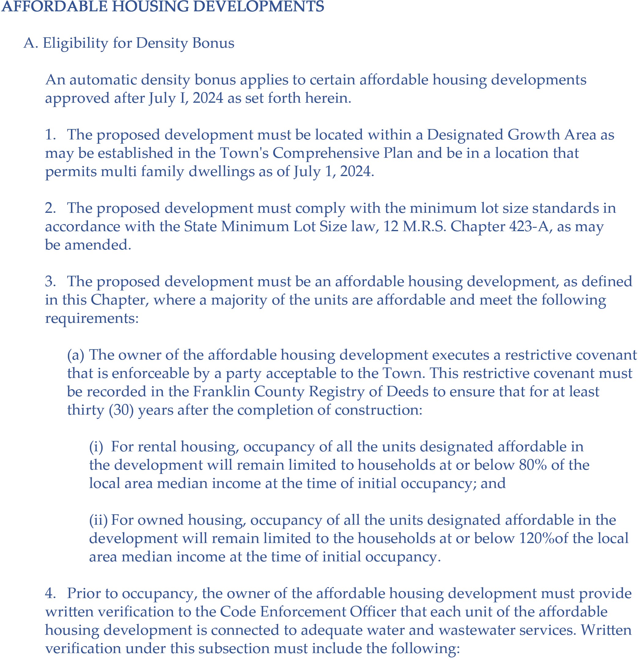

1. If a housing unit is connected to a public, special district or other comparable sewer system, proof of adequate service to support any additional ﬂow created by the unit and proof of payment for the connection to the sewer system;
2. If a housing unit is connected to a septic system, proof of adequate sewage disposal for subsurface wastewater. Tue septic system must be veriﬁed as adequate by the Local Plumbing Inspector pursuant to 30-A M.R.S. § 4221, as may

be amended. Plans for subsurface wastewater disposal must be prepared by a licensed site evaluator in accordance with 10-144 C.M.R. Ch. 241, Subsurface Wastewater Disposal Rules;

( c) If a housing unit is connected to a public, special district or other centrally managed water system, proof of adequate service to support any additional ﬂow created by the unit, proof of payment for the connection and the volume and supply of water required for the unit; and

( d) If a housing unit is connected to a well, proof of access to potable water, including the standards outlined in 01-672 C.M.R. Ch. 10 § 10.25(]), Land Use Districts and Standards, as may be amended. Any test of an existing well or proposed well must indicate that the water supply is potable and acceptable for domestic use.

5. At least two oﬀ-street parking spaces for motor vehicles must be provided for every three dwelling units of an aﬀordable housing development.

B. Density Bonus

If the requirements of §15-105(A) are met, the proposed development may have a dwelling unit density of not more than 2.5 times the base density that is otherwise allowed in that location. If fractional results occur when calculating the density bonus, the number of units is rounded down to the nearest whole number.